Climate Trends and Variations Bulletin – Winter 2018/2019
This bulletin summarizes recent climate data and presents it in a historical context. It first examines the national average temperature for the season and then highlights interesting regional temperature information.
Over the past decade, precipitation monitoring technology has evolved and Environment and Climate Change Canada and its partners implemented a transition from manual observations to using automatic precipitation gauges. Extensive data integration is required to link the current precipitation observations to the long term historical manual observations. The update and reporting of historical adjusted precipitation trends and variations will be on temporary hiatus pending the extensive data reconciliation, and resumed thereafter. ECCC remains committed to providing credible climate data to inform adaptation decision making, while ensuring the necessary data reconciliation occurs as monitoring technology evolves.
National Temperature
The national average temperature for the winter (December-February) of 2018/2019 was 1.1°C above the baseline average (defined as the mean over the 1961–1990 reference period), based on preliminary data, which is the 29th warmest observed since nationwide recording began in 1948. The warmest winter occurred in 2009/2010, when the national average temperature was 4.1°C above the baseline average. The coldest winter occurred in 1971/1972, when the national average temperature was 3.6°C below the baseline average. The temperature departures map (below) shows that Yukon, Northwest Territories, Nunavut, the northern parts of British Columbia, Alberta, Saskatchewan, Manitoba, and Ontario, Quebec, Newfoundland as well as southern Ontario experienced temperatures above the baseline average. Meanwhile, some areas in southern British Columbia, Alberta, Saskatchewan, Manitoba, Quebec and Atlantic Canada experienced winter temperatures below the baseline average. Winter temperatures were near the baseline average in the remainder of the country.
Temperature Departures from the 1961–1990 Average – Winter 2018/2019
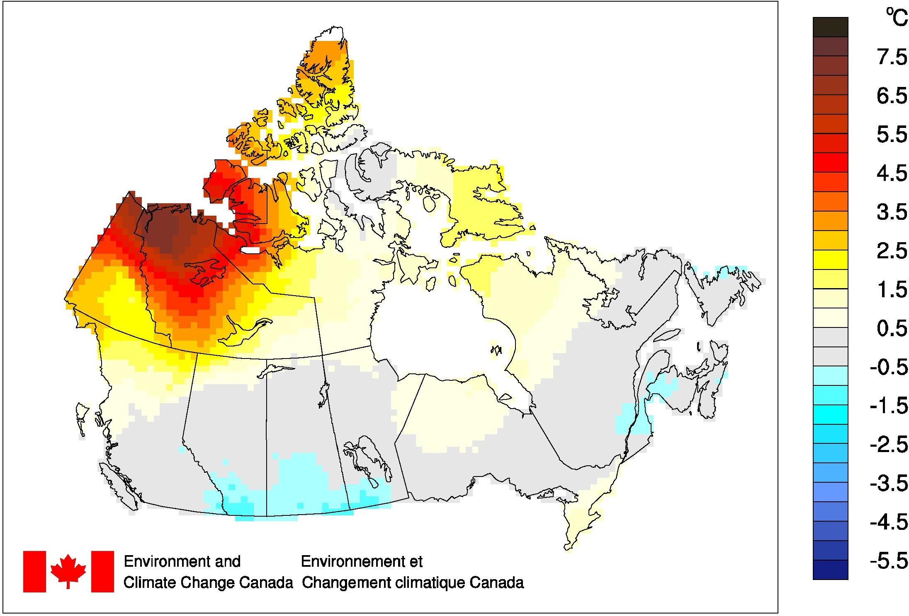
The time series graph (below) shows that averaged winter temperatures across the country have fluctuated from year to year over the 1948–2019 period. The linear trend indicates that winter temperatures averaged across the nation have warmed by 3.3°C over the past 72 years.
Winter National Temperature Departures and Long-term Trend, 1948–2019
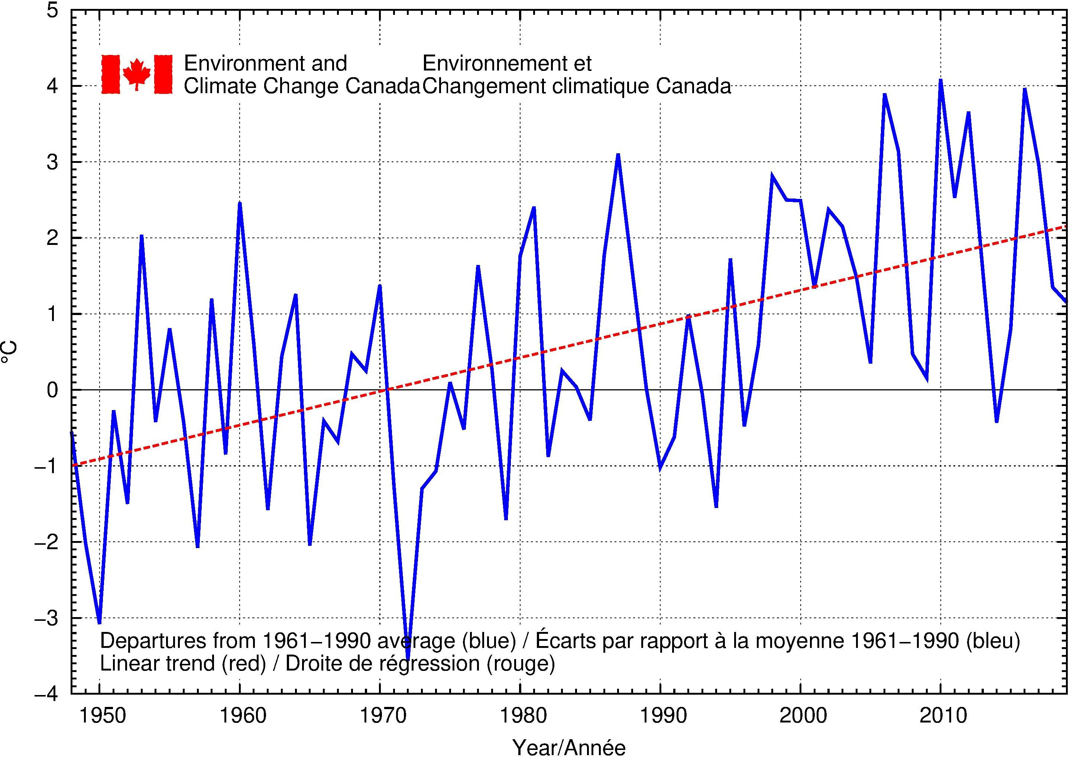
Regional Temperature
When examined on a regional basis, none of the eleven climate regions experienced an average winter temperature for 2018/2019 that ranked among the 10 warmest or coldest since 1948. All eleven climate regions exhibit positive trends for winter temperatures over the 72 years of record. The strongest regional trend (+5.7°C) is observed in the Yukon/North B.C. Mountains region, while the weakest trend (+0.6°C) is found in the Atlantic Canada region. A table listing the regional and national temperature departures and rankings from 1948 to 2019 and a table that summarizes regional and national trends and extremes summaries are available on request to ec.btvc-ctvb.ec@canada.ca.

