Climate Trends and Variations Bulletin – Spring 2019
This bulletin summarizes recent climate data and presents it in a historical context. It first examines the national average temperature for the season and then highlights interesting regional temperature information.
Over the past decade, precipitation monitoring technology has evolved and Environment and Climate Change Canada and its partners implemented a transition from manual observations to using automatic precipitation gauges. Extensive data integration is required to link the current precipitation observations to the long term historical manual observations. The update and reporting of historical adjusted precipitation trends and variations will be on temporary hiatus pending the extensive data reconciliation, and resumed thereafter. ECCC remains committed to providing credible climate data to inform adaptation decision making, while ensuring the necessary data reconciliation occurs as monitoring technology evolves.
National Temperature
The national average temperature for the spring (March-May) of 2019 was 1.6°C above the baseline average (defined as the mean over the 1961–1990 reference period), based on preliminary data, which is the 13th warmest observed spring since nationwide recording began in 1948. The warmest spring occurred in 2010, when the national average temperature was 4.0°C above the baseline average. The coldest spring occurred in 1974, when the national average temperature was 2.0°C below the baseline average. The temperature departures map (below) shows that Yukon, Northwest Territories, Nunavut, most of British Columbia, the northern parts of Alberta, Saskatchewan, Manitoba, Quebec and Newfoundland and Labrador experienced temperatures above the baseline average. Meanwhile, the southern parts of Alberta, Saskatchewan, Manitoba, Quebec, much of Ontario and Atlantic Canada experienced spring temperatures below the baseline average. Spring temperatures were near the baseline average in the remainder of the country.
Temperature Departures from the 1961–1990 Average – Spring 2019
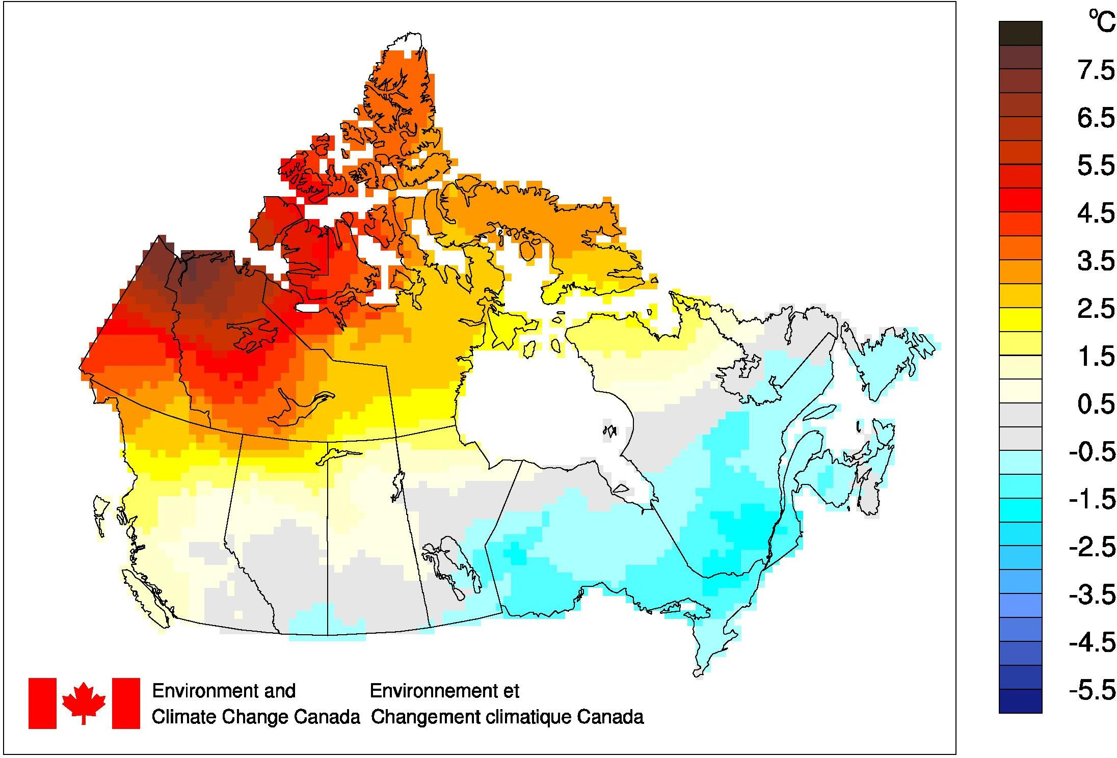
The time series graph (below) shows that averaged spring temperatures across the country have fluctuated from year to year over the 1948–2019 period. The linear trend indicates that spring temperatures averaged across the nation have warmed by 1.7°C over the past 72 years.
Spring National Temperature Departures and Long-term Trend, 1948–2019
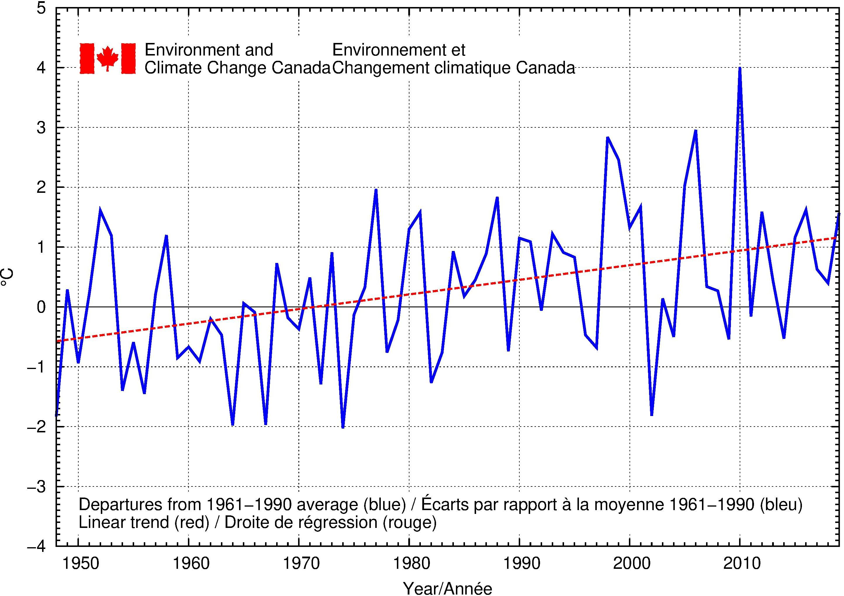
Regional Temperature
When examined on a regional basis, average spring temperatures for 2019 were among the 10 warmest recorded since 1948 for five of the eleven climate regions: Yukon/North B.C. Mountains (2nd warmest at 4.1°C above average), Mackenzie District (3rd warmest at 4°C above average), Arctic Tundra (3rd warmest at 3.4°C above average), Arctic Mountains and Fiords (5th warmest at 3.3°C above average) and the Pacific Coast (9th warmest at 1.4°C above average). Average spring temperatures for 2019 were among the 10 coldest on record for one of the eleven climate regions: Great Lakes/St. Lawrence (10th coldest at 1.1°C below average). All eleven climate regions exhibit positive trends for spring temperatures over the 72 years of record. The strongest regional trend (+2.8°C) is observed in the Yukon/North B.C. Mountains and the Mackenzie District, while the weakest trend (+0.7°C) is found in Atlantic Canada. A table listing the regional and national temperature departures and rankings from 1948 to 2019 and a table that summarizes regional and national trends and extremes summaries are available on request to ec.btvc-ctvb.ec@canada.ca.

