Climate Trends and Variations Bulletin – Autumn 2018
This bulletin summarizes recent climate data and presents it in a historical context. It first examines the national average temperature for the season and then highlights interesting regional temperature information.
Over the past decade, precipitation monitoring technology has evolved and Environment and Climate Change Canada and its partners implemented a transition from manual observations to using automatic precipitation gauges. Extensive data integration is required to link the current precipitation observations to the long term historical manual observations. The update and reporting of historical adjusted precipitation trends and variations will be on hiatus pending the extensive data reconciliation, and resumed thereafter. ECCC remains committed to providing credible climate data to inform adaptation decision making, while ensuring the necessary data reconciliation occurs as monitoring technology evolves.
National Temperature
The national average temperature for the autumn (September–November) of 2018 was 0.8°C below the baseline average (defined as the mean over the 1961–1990 reference period), based on preliminary data, which is the 8th coldest observed since nationwide recording began in 1948. The warmest autumn occurred in 1998, when the national average temperature was 2.5°C above the baseline average. The coldest autumn occurred in 1972, when the national average temperature was 1.8°C below the baseline average. The temperature departures map (below) shows that the Yukon, the northwestern areas of the Northwest Territories and Nunavut, as well as western British Columbia experienced autumn temperatures notably above the baseline average. Meanwhile, the southeastern part of the Northwest Territories, southern Nunavut, as well as most of Alberta, Saskatchewan, Manitoba, Ontario, Quebec, and Atlantic Canada saw temperatures well below the baseline average. Autumn temperatures were generally near the baseline average in the remainder of the country.
Temperature Departures from the 1961–1990 Average – Autumn 2018

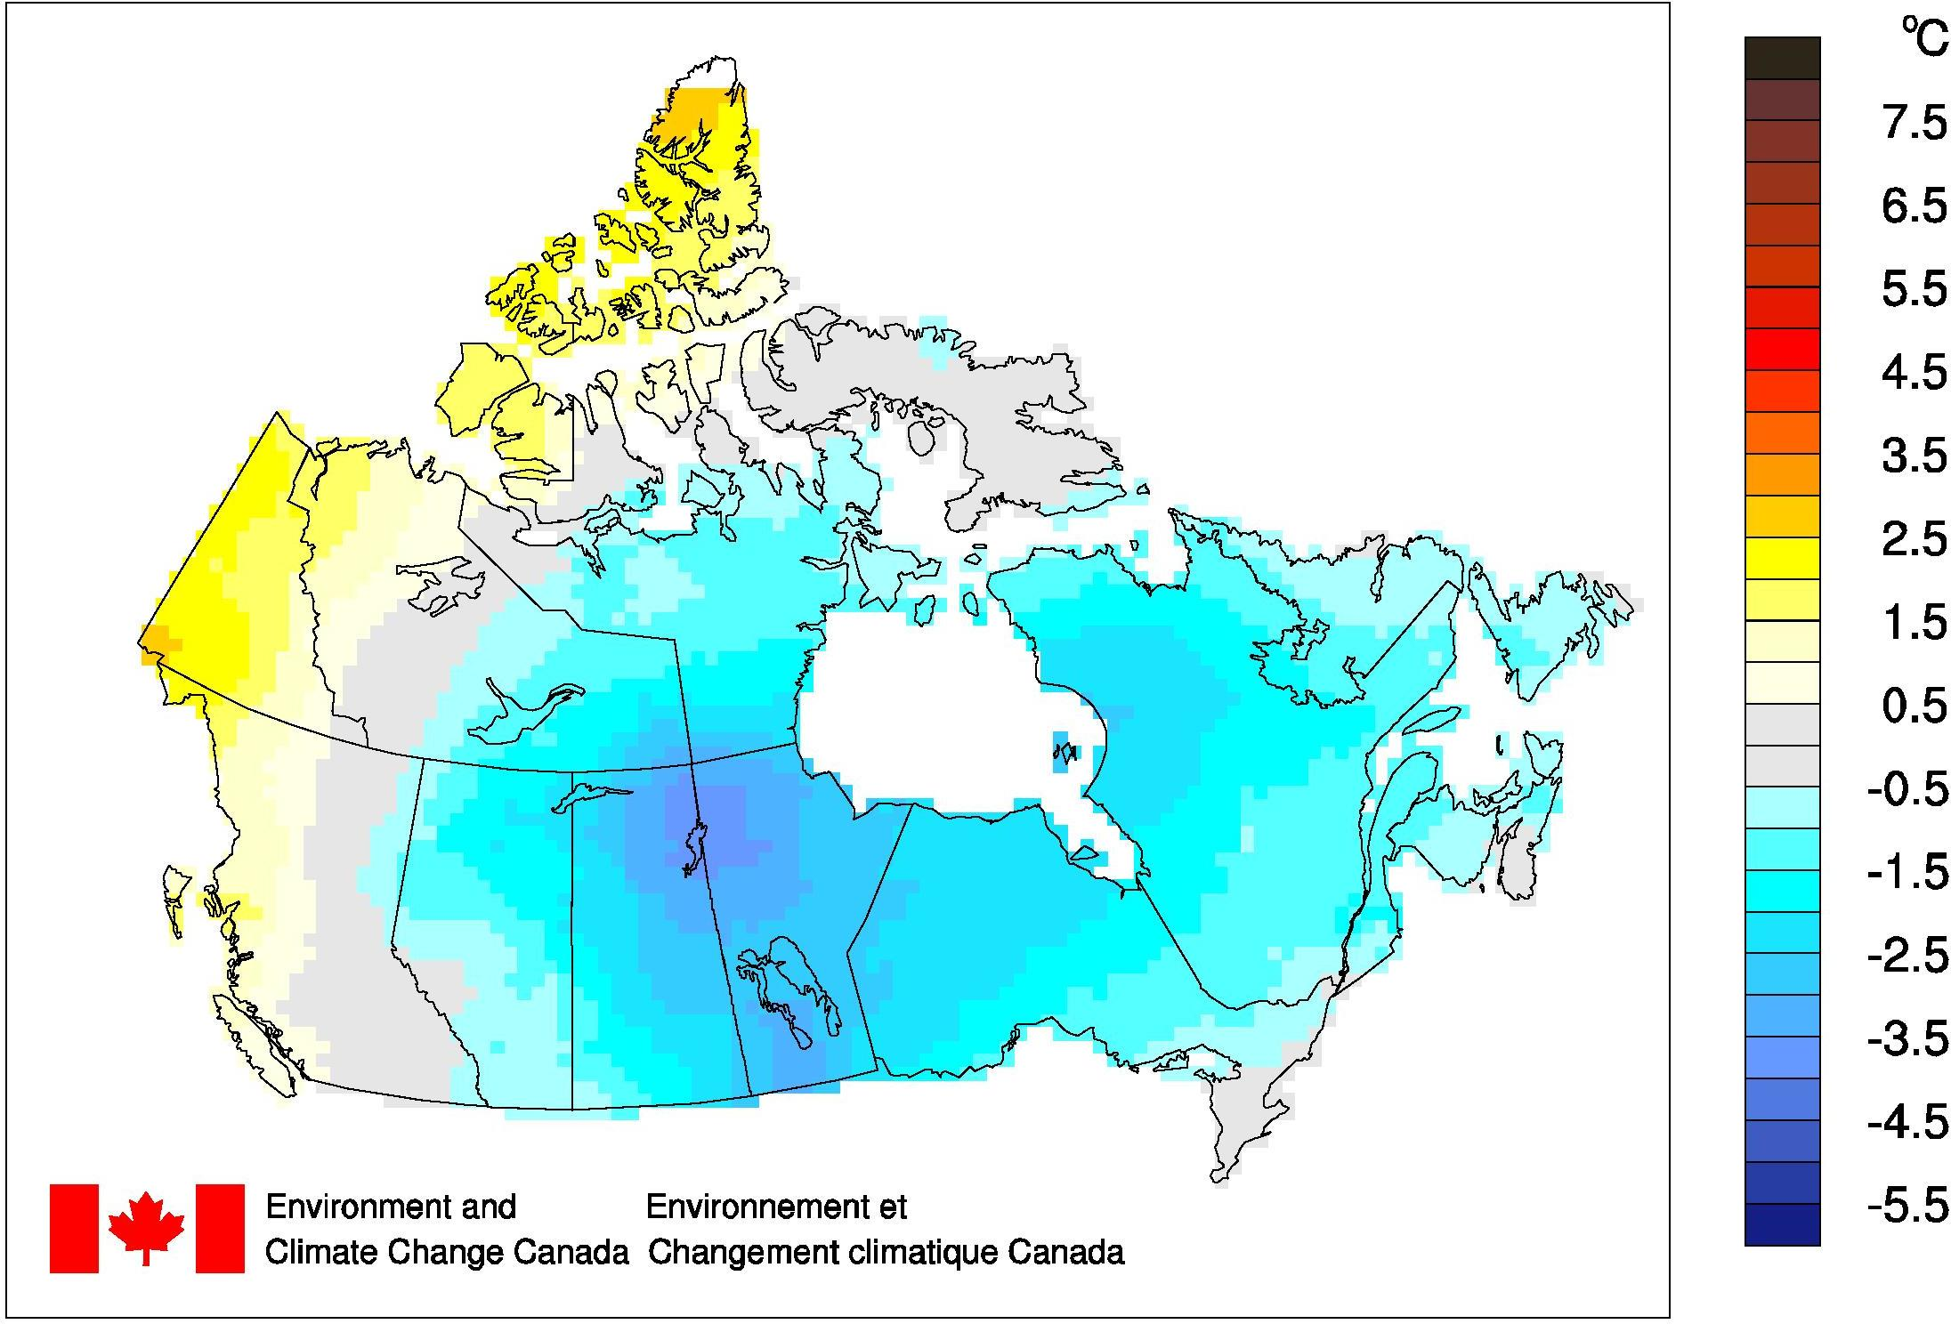
The time series graph (below) shows that autumn temperatures averaged across the country have fluctuated from year to year over the 1948–2018 period. The linear trend indicates that autumn temperatures averaged across the nation have warmed by 1.6°C over the past 71 years.
Autumn National Temperature Departures and Long-term Trend, 1948–2018

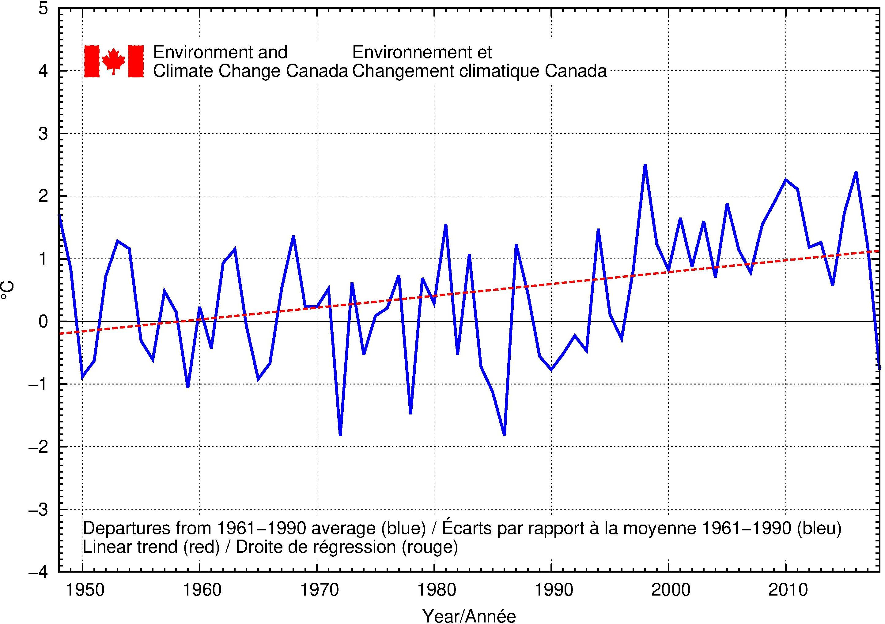
Regional Temperature
When examined on a regional basis, average autumn temperatures for 2018 were among the 10 warmest recorded in that region since 1948 for one of the eleven climate regions: the Pacific Coast (6th warmest at 1.0°C above average). Average autumn temperatures for 2018 were among the 10 coldest on record for four of the eleven climate regions: Atlantic Canada (7th coldest at 0.8°C below average), the Northeastern Forest (5th coldest at 1.7°C below average), the Northwestern Forest (4th coldest at 2.2°C below average), and the Prairies (7th coldest at 1.8°C below average). All eleven climate regions exhibit positive trends for autumn temperatures over the 71 years of record. The strongest trend is observed in the Arctic Tundra and Arctic Mountains and Fiords regions (+2.4°C), while the weakest trend (+0.5°C) is found in the South B.C. Mountains region. A table listing the regional and national temperature departures and rankings from 1948 to 2018 and a table that summarizes regional and national trends and extremes summaries are available on request to ec.btvc-ctvb.ec@canada.ca.

