Climate Trends and Variations Bulletin – Annual 2018
This bulletin summarizes recent climate data and presents it in a historical context. It first examines the national average temperature for the year and then highlights interesting regional temperature information.
Over the past decade, precipitation monitoring technology has evolved and Environment and Climate Change Canada and its partners implemented a transition from manual observations to using automatic precipitation gauges. Extensive data integration is required to link the current precipitation observations to the long term historical manual observations. The update and reporting of historical adjusted precipitation trends and variations will be on hiatus pending the extensive data reconciliation, and resumed thereafter. ECCC remains committed to providing credible climate data to inform adaptation decision making, while ensuring the necessary data reconciliation occurs as monitoring technology evolves.
National Temperature
The national average temperature for the year 2018 (January to December) was 0.5°C above the baseline average (defined as the mean over the 1961–1990 reference period), based on preliminary data, which is the 29th warmest observed since nationwide recording began in 1948. The warmest year occurred in 2010, when the national average temperature was 3°C above the baseline average. The coldest year occurred in 1972, when the national average temperature was 2°C below the baseline average. The temperature departures map (below) shows that the Yukon, most of the Northwest Territories, as well as parts of Nunavut and British Columbia experienced temperatures notably above the baseline average in 2018. Meanwhile, parts of northern Quebec experienced temperatures well below the baseline average. Annual temperatures were generally near the baseline average in the remainder of the country.
Temperature Departures from the 1961–1990 Average – Annual 2018

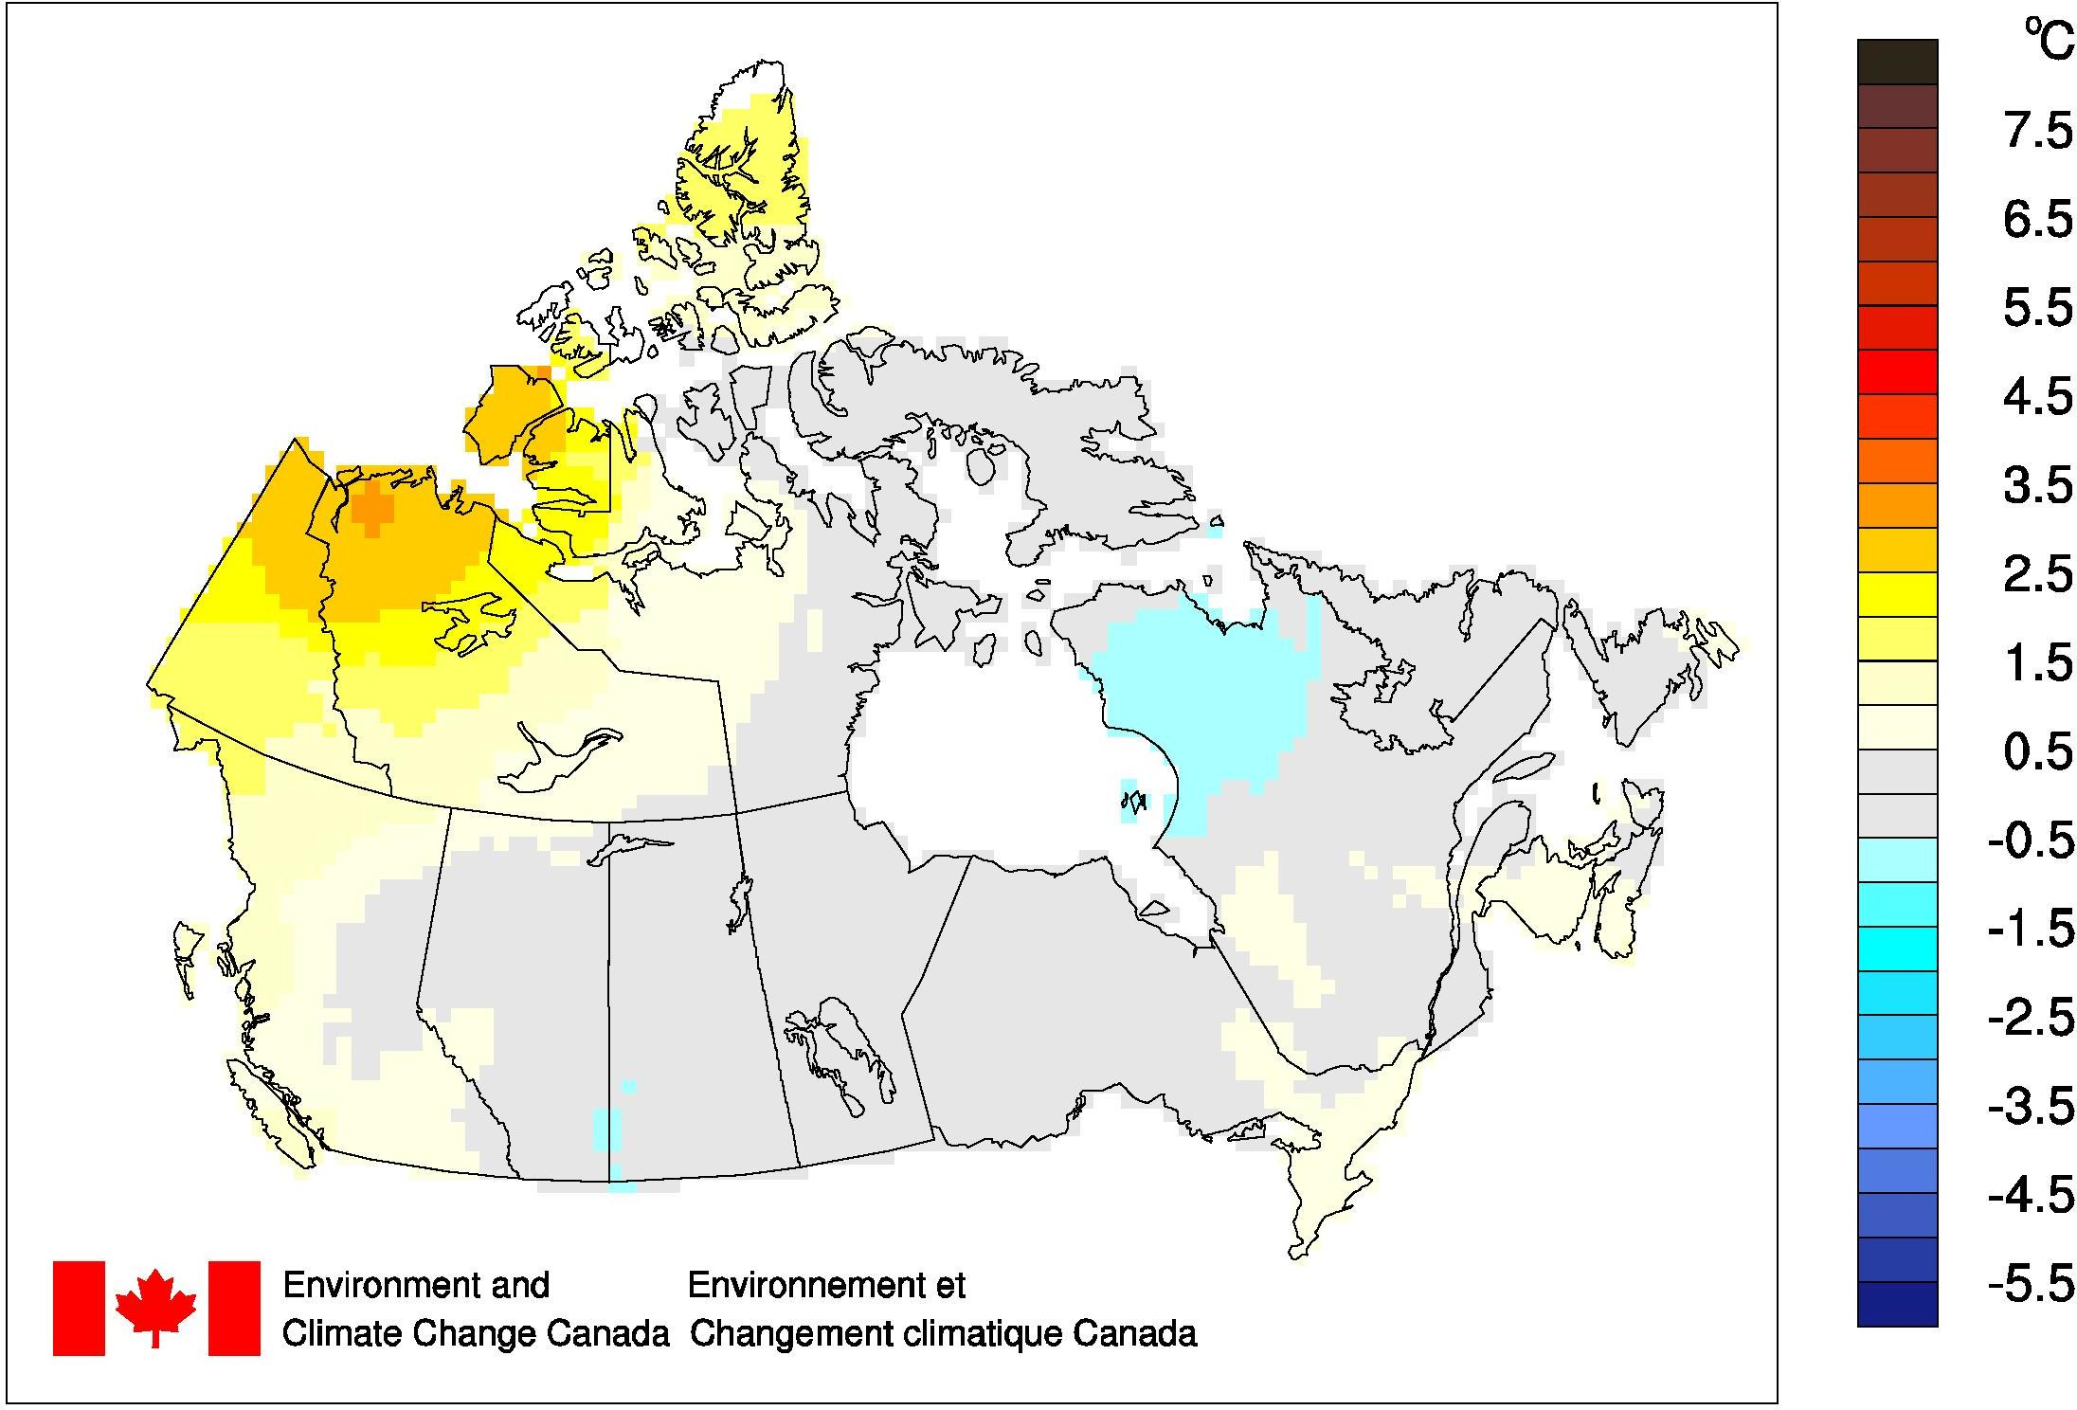
The time series graph (below) shows that averaged annual temperatures across the country have fluctuated from year to year over the 1948–2018 period. The linear trend indicates that annual temperatures averaged across the nation have warmed by 1.7°C over the past 71 years.
Annual National Temperature Departures and Long-term Trend, 1948–2018
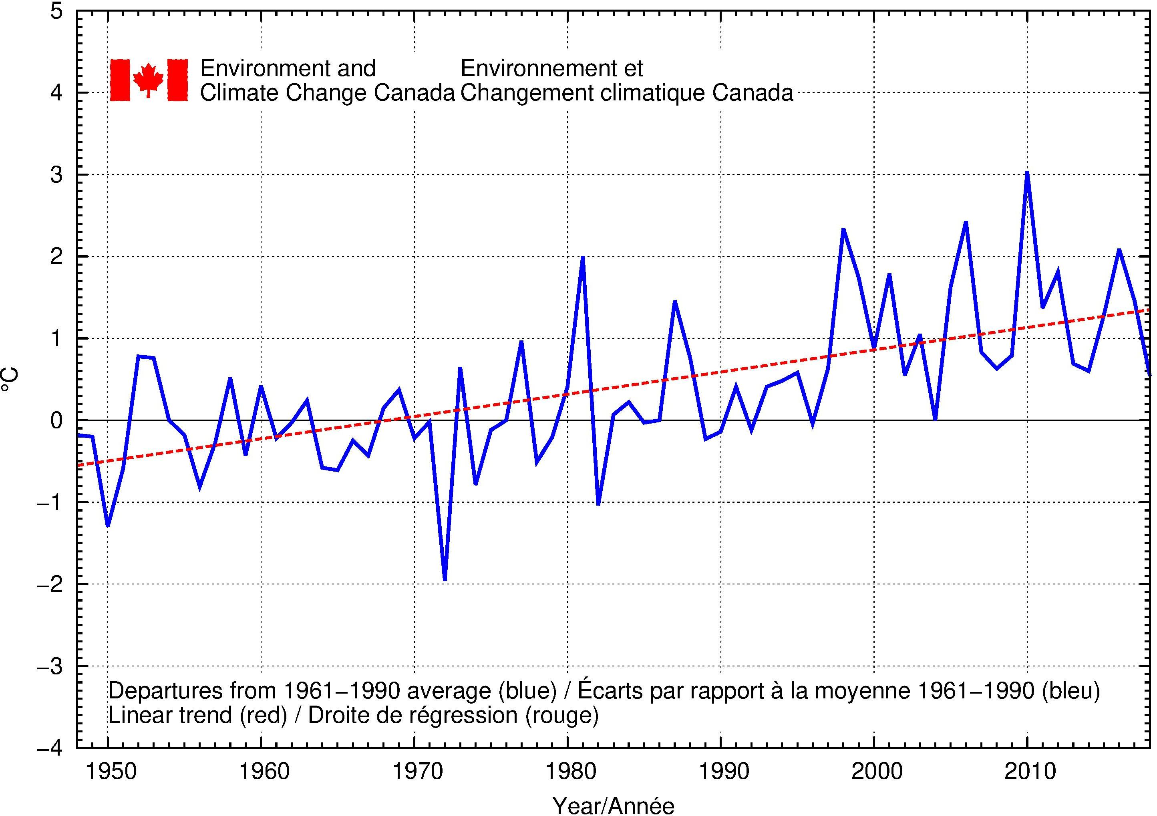

Regional Temperature
When examined on a regional basis, the average annual temperature for 2018 was among the 10 warmest on record since 1948 for one of the eleven climate regions: the Yukon/North B.C. Mountains region (9th warmest at 1.8°C above average). None of the eleven climate regions experienced an average annual temperature for 2018 that ranked among the 10 coldest since 1948. All eleven climate regions exhibit positive trends for annual temperature over the 71 years of record. The strongest regional trend (+2.8°C) is observed in the Mackenzie District region, while the weakest trend (+0.8°C) is found in the Atlantic Canada region. A table listing the regional and national temperature departures and rankings from 1948 to 2018 as well as a table that summarizes regional and national trends and extremes are available on request to ec.btvc-ctvb.ec@canada.ca.

